No. | Answer
a 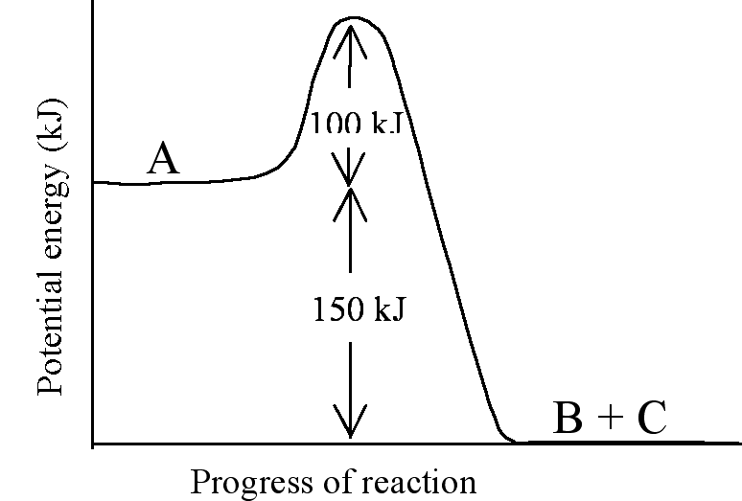
b E_{A} for the reverse reaction = 250 kJ
c The activation energy peak will be less than 100 kJ, but the energies of the reactant and products must stay the same (∆H does not change for a catalysed reaction)
 | Solid catalysts rely on reactant molecules adsorbing onto the surface of the catalyst. Pellets and wire gauzes both maximise the available surface area of the catalyst and so increase its efficiency.
 | Biological catalysts are known as enzymes.
 | Enzymes are extraordinarily efficient, but generally operate under only very mild conditions of temperature, pressure and pH, as found in the body. Any significant change from these conditions and the enzymes are denatured (cease to function). For these reasons they cannot be used in the majority of industrial processes.
Many catalysts function by providing a surface to which the reactant molecules can adsorb. As the molecules ‘stick’ to the surface of the catalyst their bond strength is decreased and the molecules break apart more readily. This has the effect of lowering the activation energy of the reaction. As the catalyst is merely providing a surface on which the reaction is initiated, it does not physically take part in the reaction and so remains unaffected.
Some catalysts actually take part in the reaction, but are regenerated at some stage during the reaction back to their original form. That is, they are not consumed in the reaction but, by providing an alternative pathway in which they participate, they speed up the reaction rate.

